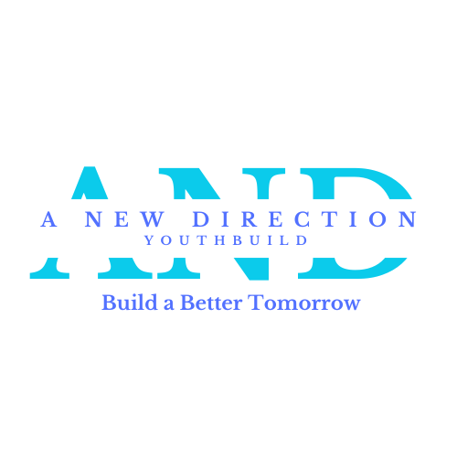
SC Regional Housing Authority #3
10980 Ellenton Street, Barnwell, SC 29812
A New Direction YouthBuild

The following information is used to determine eligibility and will be kept confidential. Complete in PEN

Date of Application: ________/________/________

Full Name: □ She/Her □ He/Him □ They/Them □ Other Address:
City: State: Zip:

Home Phone: Cell Phone:

Email Address: U.S. Citizen □ Yes □ No Age: D.O.B. Social Security Number: / /
Have you registered for the Selective Service? (Male applicants over the age of 18) □ Yes □ No □ Not Applicable Are you of Hispanic or Latino Origin? □ Yes □ No □ Not Specified
Please mark all that apply:
□ Native North American □ Hawaiian Native or Pacific Islander □ Asian □ White
□ Black or African American □ Not Specified
Please mark all fields that apply:
□ Migrant Youth □ Low-income Family □ Youth in Foster Care □ High School Dropout
□ Youth Offender □ Child of Incarcerated Parent □ Adult Offender □ SNAP (food stamps)
□ Social Security Disability Insurance (SSDI) □ Supplemental Security Income (SSI)
□ Temporary Assistance to Needy Families (TANF) □ Unemployment □ Subsidized Housing
□ Other:

Please list your emergency contacts, numbers should be different from your home numbers:

Emergency Contact 1:
Name Relationship Phone

Emergency Contact 2:
Name Relationship Phone

EDUCATIONAL BACKGROUND
Do you have a High School Diploma? □ Yes □ No Do you have a GED? □ Yes □ No Have you completed the 8th grade? □ Yes □ No
What is the last school you attended?

WORK HISTORY
Are you currently working? □ Yes □ No Is your job? □ Part-time □ Full-time What is your current hourly wage? Average number of hours worked per week?
Current Work Schedule:

Name of Business
Judicial System Involvement
Please answer this section HONESTLY—we may complete Background checks for EACH student and staff. If you are dishonest on this section it may eliminate you from selection
Have you ever been arrested, convicted or held in police custody? □ Yes □ No
If yes, please describe
Are you on probation, parole, or involved with corrections?
□ Yes □ No
If yes, probation/parole officer Phone #
** Please provide documentation of the terms of your probation and upcoming court dates.

ADDITIONAL INFORMATION
Do you have a driver’s license? □ Yes □ No
If no, do you have a learner’s permit? □ Yes □ No If accepted will you consistently attend Monday through Friday 9:00 -3:00? □ Yes □ No
Explain how you will arrive and depart each day from YouthBuild? (ex. Drop off by friend, RTS, bike, etc.)

What is your current living status (select any that apply)?
□ Living with family □ Living alone □ Living with friends □ Living in a houseless shelter
□ Living in a halfway house □ Houseless □ Other:
Are you a parent? □ Yes □ No If yes, how many children do you have and what are their age (s)?

The following list of required documents MUST be turned in with your application.

- Copy of Birth Certificate

- Copy of Driver’s License/State ID—both front and back

- Copy of Signed Social Security Card

- Copy of Medicaid Card/Insurance Card—both front and back

- Project YouthBuild Health Form

- Project YouthBuild Parent/Guardian Release (If applicant is under 18 years of age)

- Verification of household income (e.g. pay stubs, tax forms, food stamp acceptance forms)

- Verification of household size (e.g. birth certificates or SNAP print out)

- Copy of High School Transcripts (Including IEP paperwork)

Applicant Signature Date:

Parent/Guardian Signature: Date:

(Parent/Guardian signature required for applicant that is under the age of 18. By signing this form, you agree to your child’s participation with (Mental Toughness Orientation, and if accepted, the YouthBuild program.)

Parent/Guardian Printed Name:

How do I submit my application?

- Drop off in person: A New Direction YouthBuild, 10980 Ellenton Street, Barnwell, SC 29812

- Scan and Email to andyouthbuild@scrha3.org

- Mail to A New Direction YouthBuild, PO Box 1326, Barnwell, SC 29812
YouthBuild is a community-based pre-apprenticeship program that provides job training and educational opportunities for youth ages 16-24 who have previously dropped out of high school.
A New Direction YouthBuild is a Construction based program that will teach you Construction skills, Leadership Skills, as well as Entrepreneurship skills while earning your HS Diploma or GED. Participants that successfully participate in the program will earn a monthly stipend for successful participation.
Youth learn vocational skills in construction, as well as in other in-demand industries that include health care. Youth also provide community service through the required construction or rehabilitation of affordable housing for low-income or homeless families in their own neighborhoods. Youth split their time between the vocational training work site and the classroom where they earn their high school diploma or GED, learn to be community leaders, and prepare for postsecondary training opportunities, including college, apprenticeships, and employment. YouthBuild includes significant support systems, such as a mentoring, follow-up education, employment, and personal counseling services; and participation in community service and civic engagement.

Please tell us in a few words Why You feel you are a right fit for A New Direction YouthBuild: ________________________________________________________________________________________________________________________________________________________________________________________________________________________________________________________________________________________________________________________________________________________________________________________________________________________________________________________________________________________________________________________________________________________________________________________________________________________________________________________________________________________________________________________________________________________________________________________________________________________________________________________________________________________________________________________________________________________________________________________________________________________________________________________________________________________________________________________________________________________________________________________________________________________________________________________________________________________________________________________________________________________________________________________________________________________________________________________________________________________________________________________________________________________________________________________________________________________________________________________________________________________________________________________________________________________________________________________________________________________________________________________________________________________________________________________________________________

